**DAY 1**

**Shortcuts:**

| **Shortcut** | **Action** |
| --- | --- |
| **Ctrl + N** | New document |
| **Ctrl + O** | Open document |
| **Ctrl + S** | Save document |
| **Ctrl + P** | Print document |
| **Ctrl + Z** | Undo |
| **Ctrl + Y** | Redo |
| **Ctrl + X** | Cut |
| **Ctrl + C** | Copy |
| **Ctrl + V** | Paste |
| **Ctrl + A** | Select all |
| **Ctrl + B** | Bold |
| **Ctrl + I** | Italic |
| **Ctrl + U** | Underline |
| **Ctrl + E** | Center align |
| **Ctrl + L** | Left align |
| **Ctrl + R** | Right align |
| **Ctrl + J** | Justify text |
| **Ctrl + Shift + >** | Increase font size |
| **Ctrl + Shift + <** | Decrease font size |
| **Ctrl + Space** | Remove all formatting |

**Font:**

In a home tab we have Font tab like this  
 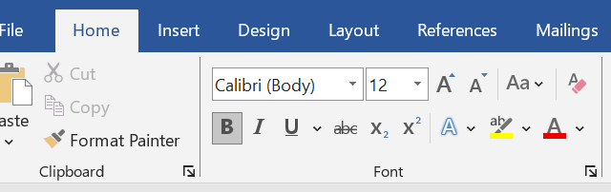

We have so many options Such us,

B for Bold letter -> **BOLD**,

I for Italic ->*ITALIC,*

U for Underline -> underline

~~abc~~ for strike line

now we going to see the font size and colour:

A boy found a tiny bird with a broken wing.  
He gently cared for it every day.   
One morning, it flew away, singing a thank-you song

**It also include Upper Case And Lower Case**

A BOY FOUND A TINY BIRD WITH A BROKEN WING .

-Upper Case

a boy found a tiny bird with a broken wing.

– Lower Case

A Boy Found A Tiny Bird With A Broken Wing.

- Capitalize Each Word

**Paragraph:**

**It Also Includes In The Home Tab, It Bullet Points,Numbering,Multi Level List,Align Left,Centre Align,Align Right,Justify,Line And Paragraph Spacing,Shading,Borders**

**1. Bullet Points**

**• Apple**

**• Banana**

**• Orange**

**2. Numbering**

**1. Wake up**

**2. Brush teeth**

**3. Go to school**

**3. Multilevel List**

**1. Fruits**

**a. Apple**

**b. Mango**

**2. Vegetables**

**a. Carrot**

**b. Potato**

**4. Align Left**

**This is left aligned.**

**5. Center Align**

**This is centered.**

**6. Align Right**

**This is right aligned.**

**7. Justify**

**This is justified text. It makes the left and right margins straight, like in newspapers.**

**8. Line and Paragraph Spacing**

**This is line one.**

**This is line two. (More space between lines)**

**9. Shading**

* **Adds background color to text or paragraph.**

**Example:**

**(Highlighted text with yellow background)  
This is a shaded sentence.**

**10. Borders**

* **Adds border lines around text or paragraphs.**

**Example:**

**This text has a border. > THIS IS ALL BORDER**

**11. Sort (A→Z or Z→A icon)**

* **Use: Sorts selected text or table rows alphabetically (A–Z or Z–A) or numerically (1–9 or 9–1).**

**Before sort:**

* **Banana**
* **Apple**
* **Mango**

|  |  |
| --- | --- |
| **name** | **mark** |
| **basheer** | **12** |
| **ahamed** | **34** |

**After sort:**

* **Apple**
* **Banana**
* **Mango**

|  |  |
| --- | --- |
| **name** | **mark** |
| **ahamed** | **34** |
| **basheer** | **12** |

**Insert**

**Table**

* **Go to the "Insert" Tab** on the Ribbon.
* Click on **“Table”**.
* A grid will appear — drag your mouse to choose how many **rows and columns** you need (e.g., 3×4 table).
* Click to insert the table.

|  |  |  |
| --- | --- | --- |
| Name | Native | Qualification |
| Basheer | veeracholan | MCA |
| Ahamed | kadayanallur | BCA |

**Image**

* **Go to the "Insert" Tab** on the Ribbon.
* Click on **“Pictures”**.
* Choose one of the following:
* **This Device** – to insert an image from your computer.
* **Online Pictures** – to insert from the internet (if available).
* Select the image you want and click **Insert** 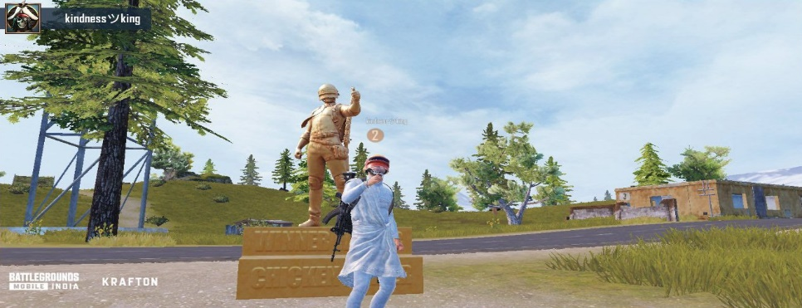

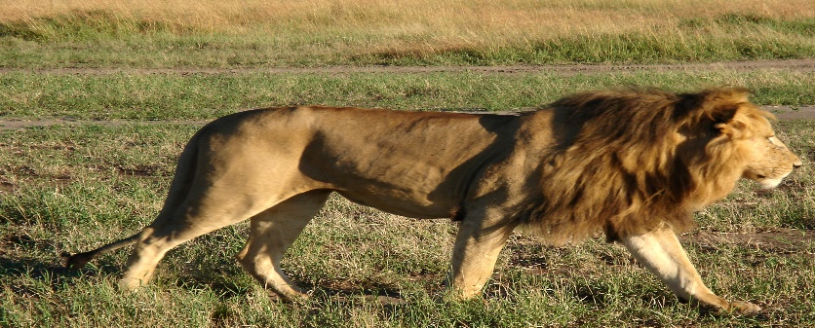

[This Photo](http://commons.wikimedia.org/wiki/File:African_Lion_3.jpg) by Unknown Author is licensed under [CC BY-SA](https://creativecommons.org/licenses/by-sa/3.0/)

**Header & Footer**

* Go to the **"Insert" Tab** on the Ribbon.
* Click on **“Header** “ or **“Footer”**
* Choose a built-in style create Header.
* Type your content (e.g., document title, name, date).
* Click **“Close Header and Footer”** or press Esc

Its same for footer also

**Layout**

**1. Margins**

* **Margins are the blank spaces between the edge of the paper and your text.**
* **How to Set:  
  Go to Layout → Margins → Choose:**
  + **Normal (1" all sides)**
  + **Narrow (0.5")**
  + **Wide (1" top/bottom, 2" left/right)**
  + **Or click Custom Margins...**
* **Use Case Example: Academic papers often require 1-inch margins on all sides.**

**2. Orientation**

* **Definition: Controls whether your page is vertical or horizontal.**
* **How to Set:  
  Go to Layout → Orientation → Choose:**
  + **Portrait (Vertical)**
  + **Landscape (Horizontal)**
* **Use Case Example:**
  + **Portrait is used for letters, essays.**
  + **Landscape is used for wide tables or certificates.**

**3. Size**

* **Definition: Sets the paper size for printing.**
* **How to Set:  
  Go to Layout → Size → Choose:**
  + **A4 (21 × 29.7 cm) – commonly used in India**
  + **Letter (8.5" × 11") – used in the US**
* **Use Case Example:  
  Use A4 for school projects and job applications.**

**4. Indent**

* **Definition: Moves the paragraph's starting point inward from the margin.**
* **How to Set:  
  Go to Layout → Indent → Set:**
  + **Left indent – pushes text right**
  + **Right indent – pushes text left**
* **Use Case Example:  
  Indent first line of paragraphs for neat appearance:**

**This is an indented paragraph.**

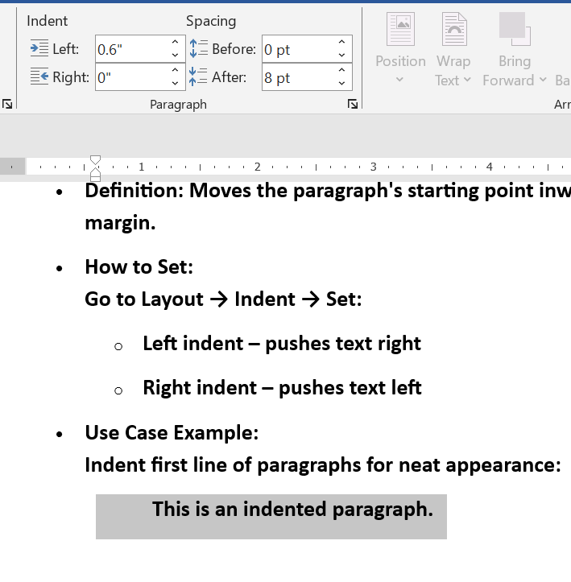

**5. Spacing**

* **Definition: Controls the space before and after a paragraph.**
* **How to Set:  
  Go to Layout → Spacing:**
  + **Before – space before the paragraph**
  + **After – space after the paragraph**
* **Use Case Example:**
  + **Set "After: 12 pt" for clear paragraph separation.**